Virtual Trivia

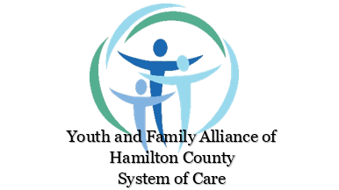

GAME NIGHT!

Join in with the Hamilton County Youth and Family Alliance and the Voice Core Team #actionfive from Breathe Easy Hamilton County
Thursday, September 10
at 6pm
on Google Meet https://meet.google.com/xhq-ptsc-mbz

Fun from the safety of your home!
Prizes!

Please join us and invite your friends to Game Night! The Youth and Family Alliance of the Hamilton County System of Care and The Action Five from Breathe Easy Hamilton County have collaborated to bring this virtual GAME NIGHT to all youth and families interested! We hope you can join us!
Click - https://meet.google.com/xhq-ptsc-mbz

