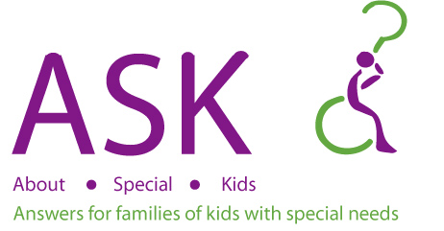

Understanding Waivers

Learn about the different types of waivers, who is eligible and what services they offer, and how to apply. The presentation will be followed by time for specific questions and answers.

Date: June 7, 2021
Time: 6:00 p.m. – 7:30 p.m.

Location: Zoom Training

Cost: FREE

Once registered, you will receive an email with a link to join the training

Register at www.aboutspecialkids.org or call 800-964-4746

.
* Funding for this training is provided through a Hoover Family Foundation grant

* Funding for this training is provided through a Hoover Family Foundation grant

* Funding for this training is provided through a Hoover Family Foundation grant

- Minimum of 6 per training is required for training to take place.

About Special Kids is a "Parent to Parent" organization that works throughout the state of Indiana to answer questions and provide support, information and resources. We are parents and family members of children with special needs and we help other families and professionals understand the various systems that are encountered related to special needs.
Mission:
About Special Kids values the power of parent-to-parent support and the vast potential of every child. We provide answers, resources, and connections vital to families raising children with special needs, preparing each family to meet their respective challenges and to achieve their goals while championing them to live their best lives.

